Computer Networking

Assignment 1 Solutions

## Solutions 1:

1) Time to send message from source host to first packet switch = $\frac{1×{10}^{6}}{5×{10}^{6}}$ sec = 0.2sec. With store-and-forward switching, the total time to move message from source host to destination host = 0.2sec×3 *hops* =0.6sec.

2) Time to send 1st packet from source host to first packet switch = $\frac{1×{10}^{4}}{5×{10}^{6}}$ sec = 2*m* sec. Time at which 2nd packet is received at the first switch = time at which 1st packet is received at the second switch

= 2 × 2*m* sec = 4 *m* sec

3) Time at which 1st packet is received at the destination host = 2 *m* sec× 3 *hops* = 6 *m* sec. After this, every 2msec one packet will be received; thus, time at which last (100th) packet is received

= 6 *m* sec+ 99 *2*m* sec = 0.204sec

It can be seen that delay in using message segmentation is significantly less (almost 1/3rd).

## Solutions 2:

1. The total amount of time to get the IP address is: RTT1 + RTT2 +Λ + RTTn . Once the IP address is known, RTTO elapses to set up the TCP connection and another RTTO elapses to request and receive the small object. The total response time is 2RTTo + RTT1 + RTT2 +Λ + RTTn
2. a) *RTT*1 +Λ + *RTTn* + 2*RTTo* + 8⋅ 2*RTTo*=18*RTTo* + *RTT*1 +Λ + *RTTn*

b) *RTT*1 +Λ + *RTTn* + 2*RTTo* + 2⋅ 2*RTTo*= 6*RTTo* + *RTT*1 +Λ + *RTTn*

c) Persistent connection with pipelining. This is the default mode of HTTP

*RTT*1 +Λ + *RTTn* + 2*RTTo* + *RTTo*= 3*RTTo* + *RTT*1 +Λ + *RTTn* .

Persistent connection without pipelining, without parallel connections.  
RTT1 +Λ + RTTn + 2RTTo +8RTTo=10RTTo + RTT1 +Λ + RTTn .

## Solutions 3:

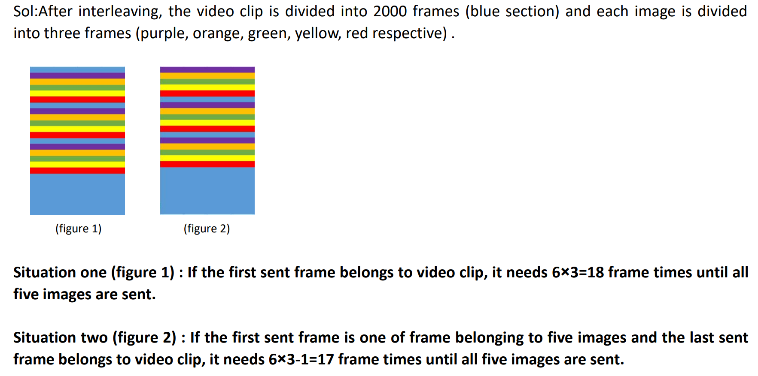

## Solutions 4:

1. The time to transmit an object of size L over a link or rate R is L/R. The average time is the average size of the object divided by R:

a = (850,000 bits)/(15,000,000 bits/sec) = 0.0567 sec

The traffic intensity on the link is given by ab=(16 requests/sec)(0.0567 sec/request) = 0.907. Thus, the average access delay is (0.0567 sec)/(1 - 0.907) ≈ 0.6 seconds. The total average response time is therefore 0.6 sec + 3 sec = 3.6 sec.

1. The traffic intensity on the access link is reduced by 60% since the 60% of the requests are satisfied within the institutional network. Thus the average access delay is (0.0567 sec)/[1 – (0.4)(0.907)] = 0.089 seconds. The response time is approximately zero if the request is satisfied by the cache (which happens with probability 0.6); the average response time is 0.089 sec + 3 sec = 3.089 sec for cache misses (which happens 40% of the time). So the average response time is (0.6)(0 sec) + (0.4)(3.089 sec) = 1.24 seconds. Thus the average response time is reduced from 3.6 sec to 1.24 sec.

## Solutions 5:

1. Yes. His first claim is possible, as long as there are enough peers staying in the swarm for a long enough time. Bob can always receive data through optimistic unchoking by other peers.
2. His second claim is also true. He can run a client on each host, let each client “free-ride,” and combine the collected chunks from the different hosts into a single file. He can even write a small scheduling program to make the different hosts ask for different chunks of the file. This is actually a kind of Sybil attack in P2P networks.